

E- Project Report

**LAB AUTOMATION**

**ACCP 2.0 (Batch: NK_2201G1)**

*Project Instructor*

**Sir Muhammad Muneeb Ullah Khan**

Submitted by:

**Abdullah Student1359157**

**Adeen Ahmed khan Student1355497**

**Muhammad Faiq Haider Student1357940**

**Declaration**

*I hear by declare that the following documented project report titled ”Lab Automation” is an authentic work done by us.*

*The project was undertaken as a park of the course curriculum of E-Project, Aptech NK. This has not been submitted to any other examination body earlier.*

*CERTIFICATE*

**This is to certify that**

**Abdullah Student1359157**

**Adeen Ahmed khan Student1355497**

**Muhammad Faiq Haider Student1357940**

Has Successfully Designed & Developed:

*“Lab Automation Website”*

*Abdullah*

*Adeen Ahmed Khan*

*Muhammad Faiq Haider*

Date of issue:

**01-01-2023**

**Preface**

In this report we are presenting about a “*LAB AUTOMATION*” that provide a website for an electric appliances where any users of internet can access is in this system user is required to login to the system and test its products.

The website provides complete information regarding appliances are the manufacturers of some electrical products like switch gears, fuses, capacitors, resistors, etc.…. These products after manufactured they are sent for testing where the product is subjected to some testing conditions, and then after the testing is successful at their laboratories, they are sent to CPRI for further testing process, so that they can get it approved from CPRI and then release the product into the market. If the testing fails then the product is sent back for re-manufacturing it and then they are again subjected to tests.

External of this project is satisfied from the team and his work and that is project team achievement. It is hope that this website will fulfill the purpose it is designed for.

Acknowledgment

First of all, we thank Almighty Allah who gives us the strength and ability to think, work and deliver what we are assigned to do.

We earnestly hope that this project will provide all the necessarily information required for the user to fulfill their inspiration. However, suggestions for improvement of the project will be thankful received & acknowledge.

**SYNOPSIS**

**LAB AUTOMATION SYSTEM:-**

A laboratory automation system consists of switch gears, fuses, capacitors, resistors and etc. Specimen movement and result reporting are based on the identification of specimens using bar coded specimens and bar coded specimen carriers .The implementation of a laboratory automation system is dependent on the presence of a laboratory information system. An interface between the laboratory information system and the laboratory automation system provides the information required to move the specimen through the laboratory.. Our Company serve the customer and satisfy then Since 2015.

**Contents**

**Chapter Introduction 08**

* Goals and objectives 09
* System Statement of scope 09
* Theoretical background 09
* Windows 10 09
* VS Code 2017 10
* HTML 5 & CSS3 10

**Chapter Problem Statement 11**

2.1 Requirement Specification 11

2.2 Hardware / Software Requirements 12

**Chapter System Estimates & Actual Outcome 13**

* Estimation Techniques applied 13
* System Estimate & actual outcome 14
* Estimation of Time for the Project 14
* Actual Time for the Project 14
* Actual Results 15
* System resources 15
* System Resources Used 15
* **Chapter Conclusion 16**

Conclusion\summary 16

4.2 List of Validation 17

**J. APPENDICES**

* Project Schedule
* Snap Shots of Project

**K. REFERENCES**

**CHAPTER 01**

**INTRODUCTION**

* **Introduction**

We are the best website that provide to easy product testing system for the customer those can’t wait and stand in a long queues and have no time to wait. So this website can help them to fulfil their demands and get some good results.

* **Goals and objectives**

Our CEO Goals Is to provide our customers comfort. Our website very useful for those customers who are not interested to waste her time to stand in a long queue.

* **System statement of scope**

A description of the entire system is presented. Major inputs, processing functionality and outputs are described without regard to implementation detail. System is represented as black box

* **Theoretical Background**

As you can see, Windows 10 pro is much more similar to older versions than it is to Windows 8. It's also faster and more secure

* **Technology & Tools/hardware components**

**1.4.1 Windows 10**

Windows 10 may very well be Microsoft’s most powerful platform ever made for organizations and their employees. Windows 10 is more familiar from a user experience standpoint. Still, it also includes so much of what businesses need—including enterprise-grade security, identity, and information protection features, which reduces complexity and proves a better experience for the business's modern needs.

**1.4.2 Visual Studio Code**

**Visual Studio Code** is a lightweight but powerful source code editor which runs on your desktop and is available for Windows, macOS and Linux. It comes with built-in support for JavaScript, TypeScript and Node.js and has a rich ecosystem of extensions for other languages (such as C++, C#, Java, Python, PHP, Go) and runtimes (such as .NET and Unity).

**1.4.3 HTML5& CSS3**

Preliminary support is added for HTML5 to the HTML editor so that you can obtain Intelligence and validation for HTML elements and attributes. A complete version that brings a fuller HTML5 experience will be provided in a future version of visual studio

**1.4.4 PHP**

PHP is mostly used for making web servers. It runs on the browser and is also capable of running in the command line. So, if you don't feel like showing your code output in the browser, you can show it in the terminal.

**1.4.5 XAMPP(MySQL)**

MySQL is an open-source relational database management system. As with other relational databases, MySQL stores data in tables made up of rows and columns. Users can define, manipulate, control, and query data using Structured Query Language, more commonly known as SQL.

**CHAPTER 02**

**PROBLEM STATEMENT**

* **Problem Statement**

The Electrical appliances are the manufacturers of some electrical products like switch gears, fuses, capacitors, resistors, etc.…. These products after manufactured they are sent for testing where the product is subjected to some testing conditions, and then after the testing is successful at their laboratories, they are sent to CPRI for further testing process, so that they can get it approved from CPRI and then release the product into the market. If the testing fails then the product is sent back for re-manufacturing it and then they are again subjected to tests.

**Requirement Specification:**

The Web site is to be created based on the following requirements.

* The Home Page should be created making use of Sections with a suitable logo
* The status of the testing and as well the detailed remarks is also needed to be captured.
* An advanced search option is needed to be included so that one can fetch the details of the testing at an ease.
* After the product is subjected for testing and if it fails it is to be sent for re-making else it will be sent for further testing procedures that are held by the CPRI and get it approved from them so as to release the product in to the market.
* After entering the record, it should even ask for the name of the person (s) who has tested the product.
* One should be able to capture the detailed description of the remarks that include about the testing and what should be the output for that testing and the result of testing performed and as well the remarks if any for that particular product.
* The details of the products and the testing like the product code, product id, testing id, the revise, the testing performed, remarks provided, the result of the testing, etc…. are needed to be maintained in a separate database.

**Hardware/ Software Requirements**

**Hardware**

* A minimum computer system that will help you access all the tools in the courses is a Pentium 166 or better
* 128 Megabytes of RAM or better

**Software**

* PHP
* MySQL
* PERL
* Apache

**CHAPTER 03**

**SYSTEM ESTIMATES & ACTUAL OUTCOME**

* **System Estimates and Actual Outcome**

Sometimes the software estimation becomes a huge below by mean of system decomposition and system resizing. System estimation and actual outcome shows your scope efforts, engineering efforts and deploy effort.

To estimate time and resources for project is a challenging task. At the initial it was such a difficult task to estimate its resources and time.

Based on the project scope, the estimation of time are discussed below

* **Estimation techniques applied and results**

There are many estimation techniques for project estimation but we considered very common and effective cost estimation by mean of exact time management. We considered the scope of estimation technique because project resources and uses may tolerate by mean of requirement**.**

* **System Estimates and Actual Outcome**
* **Estimation of time for the software**

|  |  |
| --- | --- |
| **Estimation Of time** | **Days** |
| Researching and information collecting period | 3 days |
| Analyzing other software and tools | 1 day |
| Formation of website | 26 days |
| Duration of Report | 26 days (simultaneously with project) |
| **Total time** | 30 days |

* **Actual time for the software**

|  |  |
| --- | --- |
| **Actual time** | **Days** |
| Researching and information collecting period | 3 days |
| Analyzing other software and tools | 1 day |
| Formation of website | 26 days |
| Duration of Report | 23 days (simultaneously with project) |
| **Total time** | 30 days |

* **Actual Results and Deviation from Estimates**

Actual time estimation is varied because project member was 3.

* **System Resources**

System is divided into two major parts, on the bases of which cost estimations were performed.

* Software
* Hardware

**System Resources Used**

* windows 10
* Computer
* html 5
* Php
* Visual Studio Code 2017
* CSS
* MySQL
* Apache

**CONCLUSION**

* **Conclusion / Summary**

The overall experience of this project was wonder full for the team. The members got to learn many things in fact faced many problems but, in the end, fixed them out. The features that were promised in the beginning of the project were achieved and got each and every goal of this project.

External of this project is satisfied from our team work and that is project`s team achievement. It is hoped that this application will fulfill the purpose, it is designed for.

**List of Validation**

|  |  |
| --- | --- |
| Option | Validation |
| Suitable logo on main page | Yes |
| Proper menu | Yes |
| All services details provided | Yes |
| Various pages have details about events | Yes |
| Contact us page | Yes |
| Events are properly categorized | Yes |

**Snap Shots of website:**

**“Section 1: Log In page & Customer Register Page”**

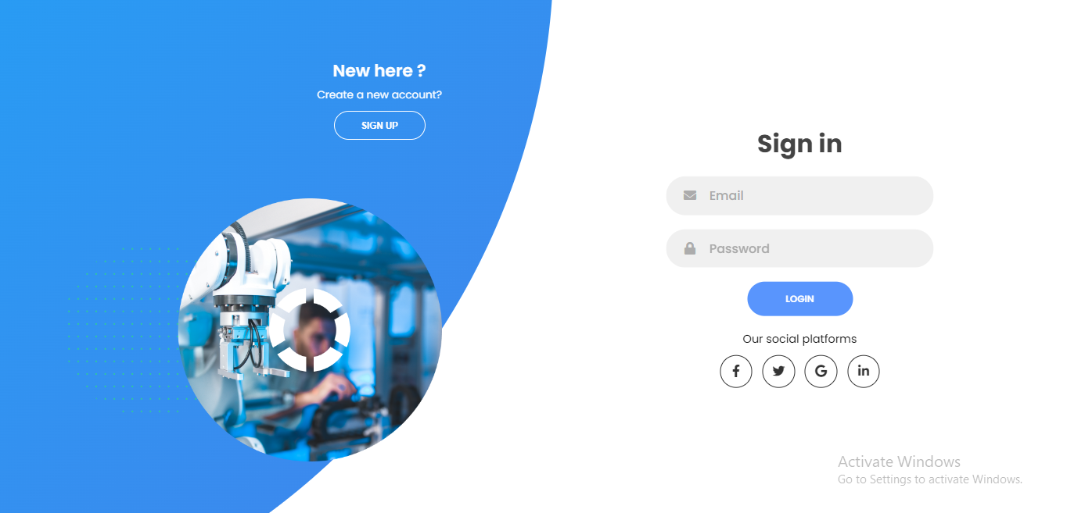

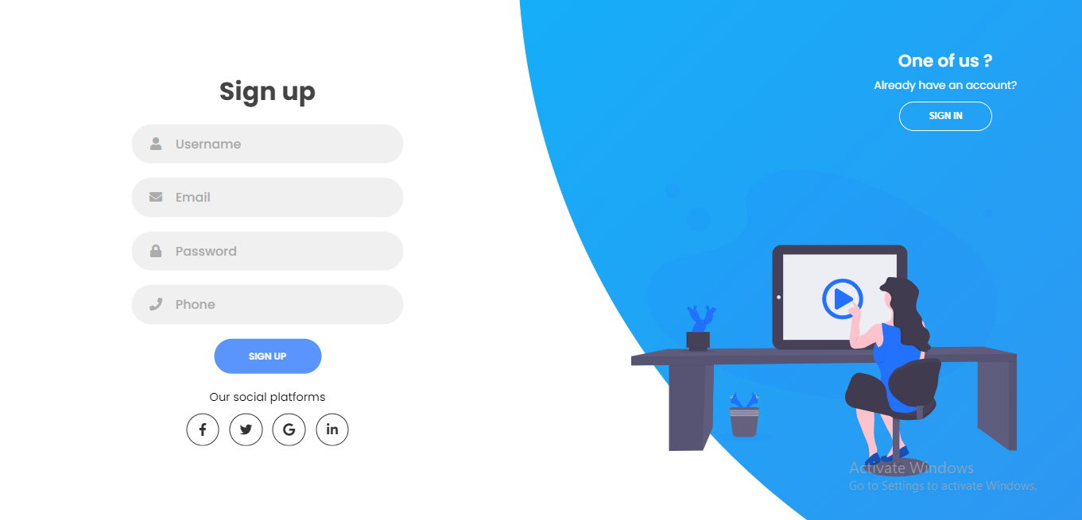

**“Section 2: Customer Home Page”**

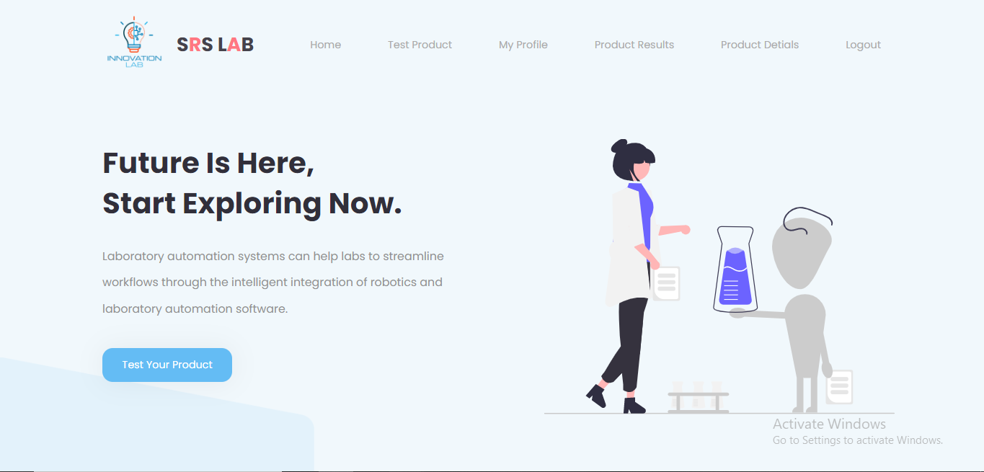

**“Section 3: Customer My Profile Page”**

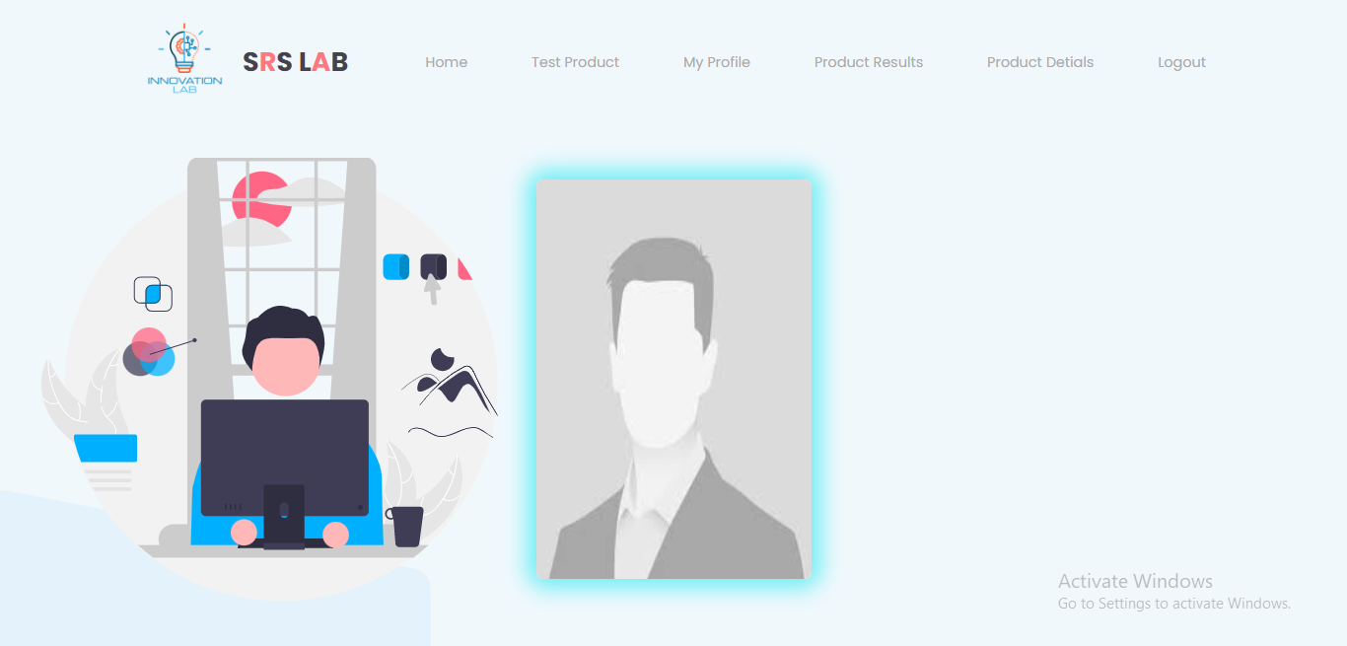

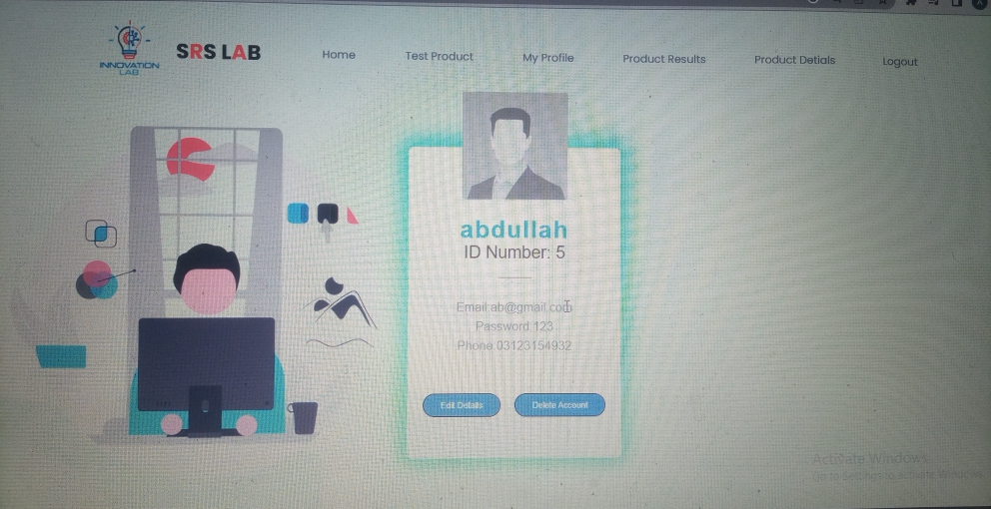

**Section 4: Edit Customer Profile Page”**

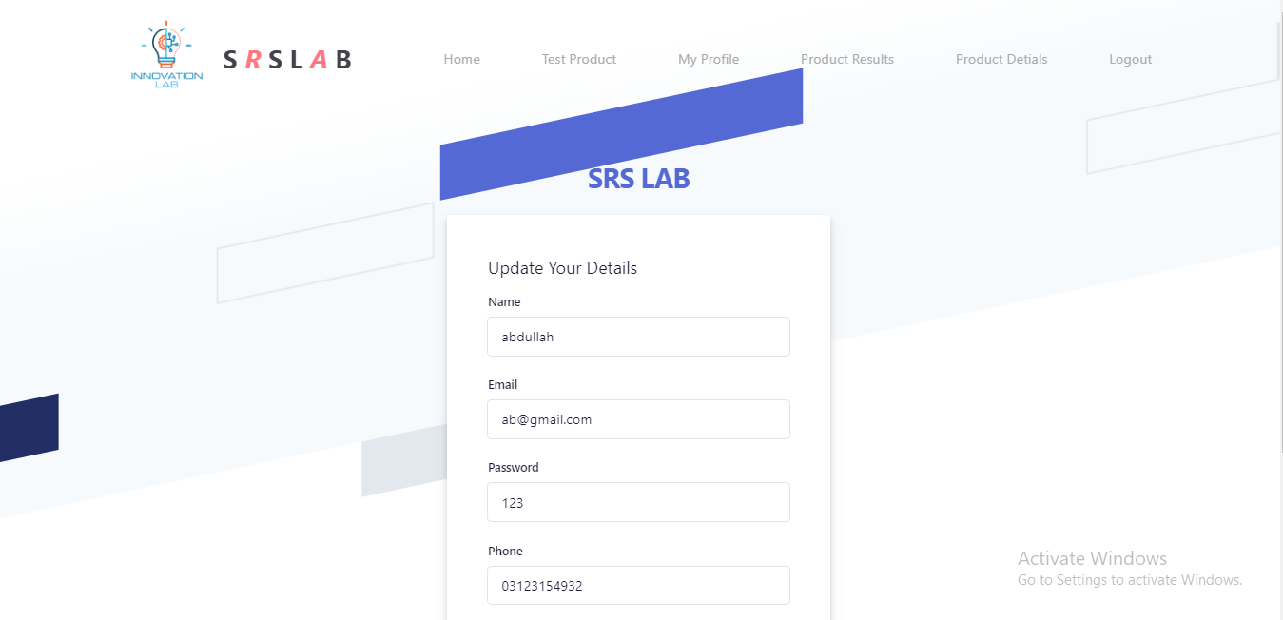

* In this page you update the details of customer

**“Section 5: “Send Product for Test”**

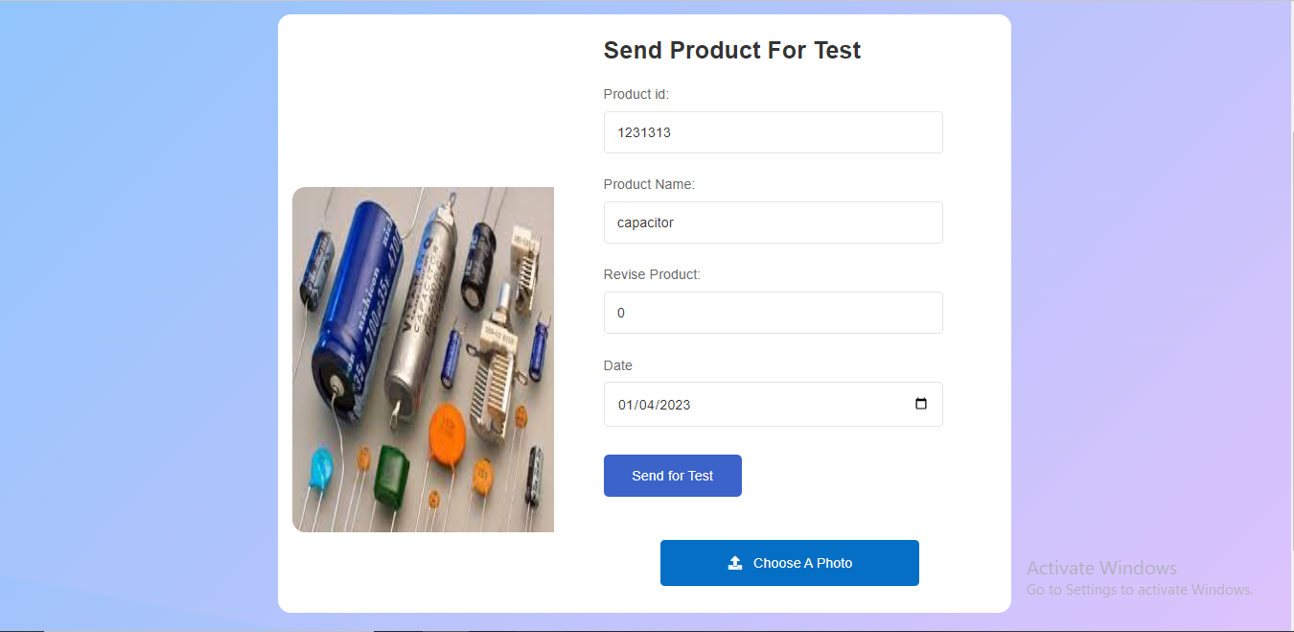

* In this page customer send his product details to lab worker for testing

**“Section 6: “Customer Product Details”**

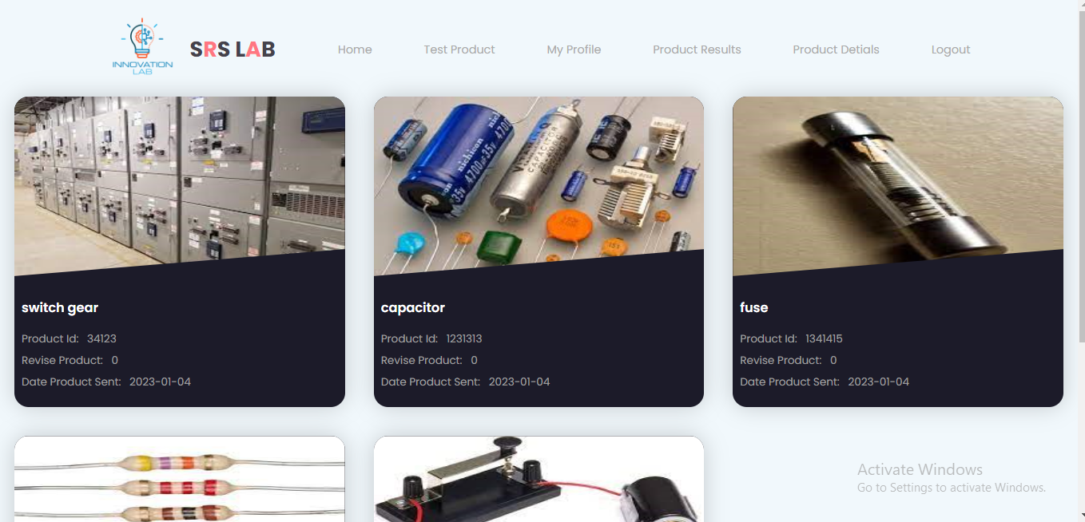

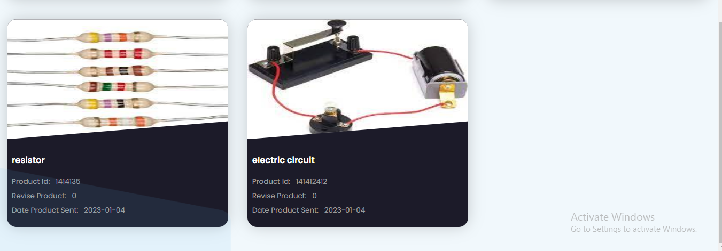

* In this page customer view his product detail he/her sent for testing until Lab worker start testing this product

**“Section 6: “Customer Product Results”**

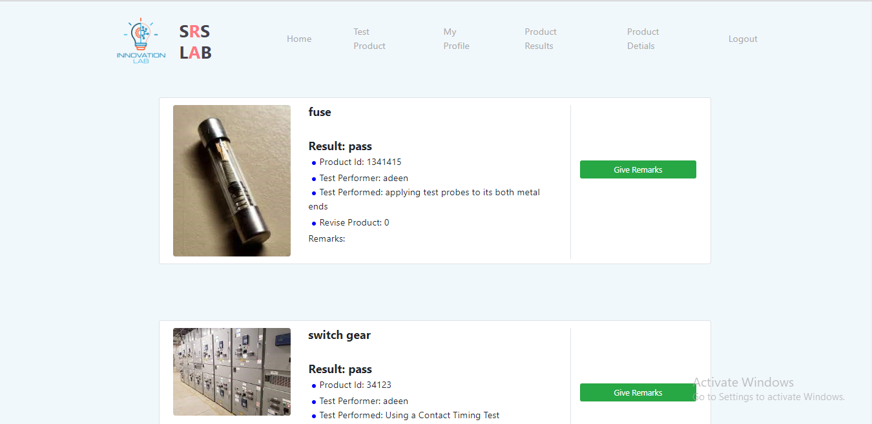

* **In this page customer view his product results**

**“Section 6: “Customer Product Results Review”**

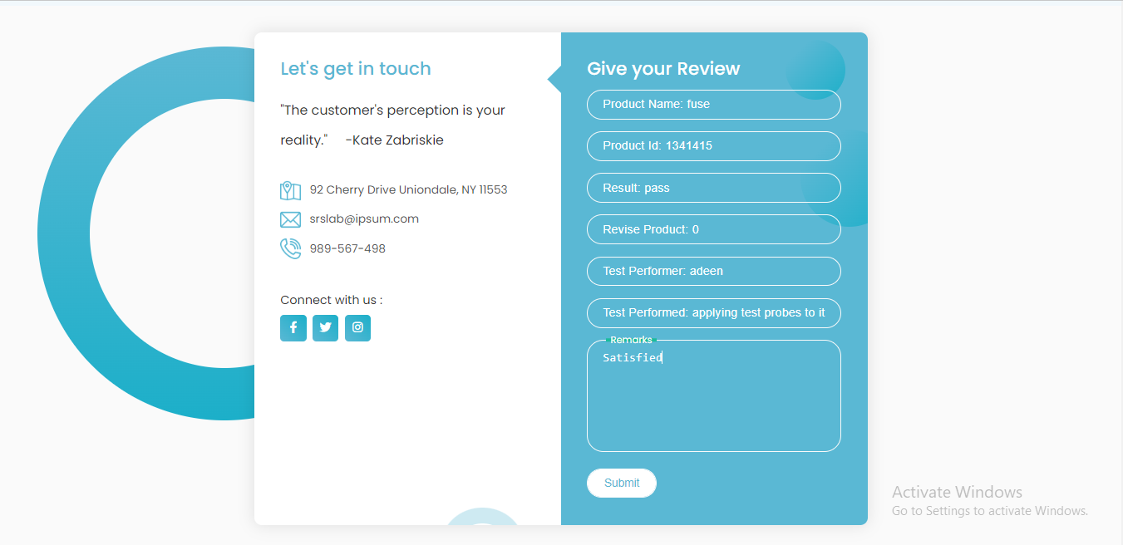

**In this page customer give review about testing**

**“Section 7: “Lab Worker Home Page”**

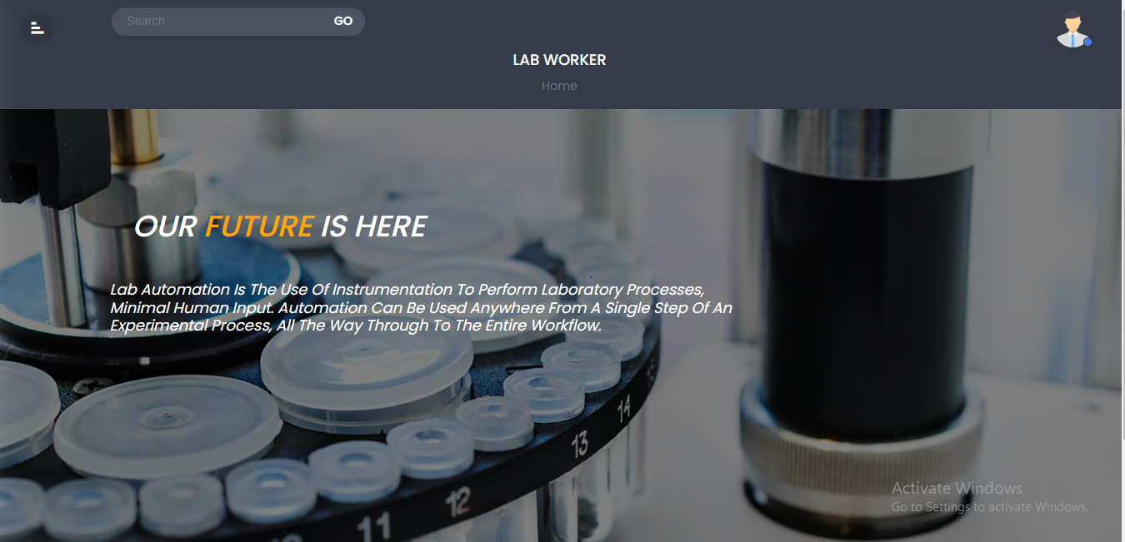

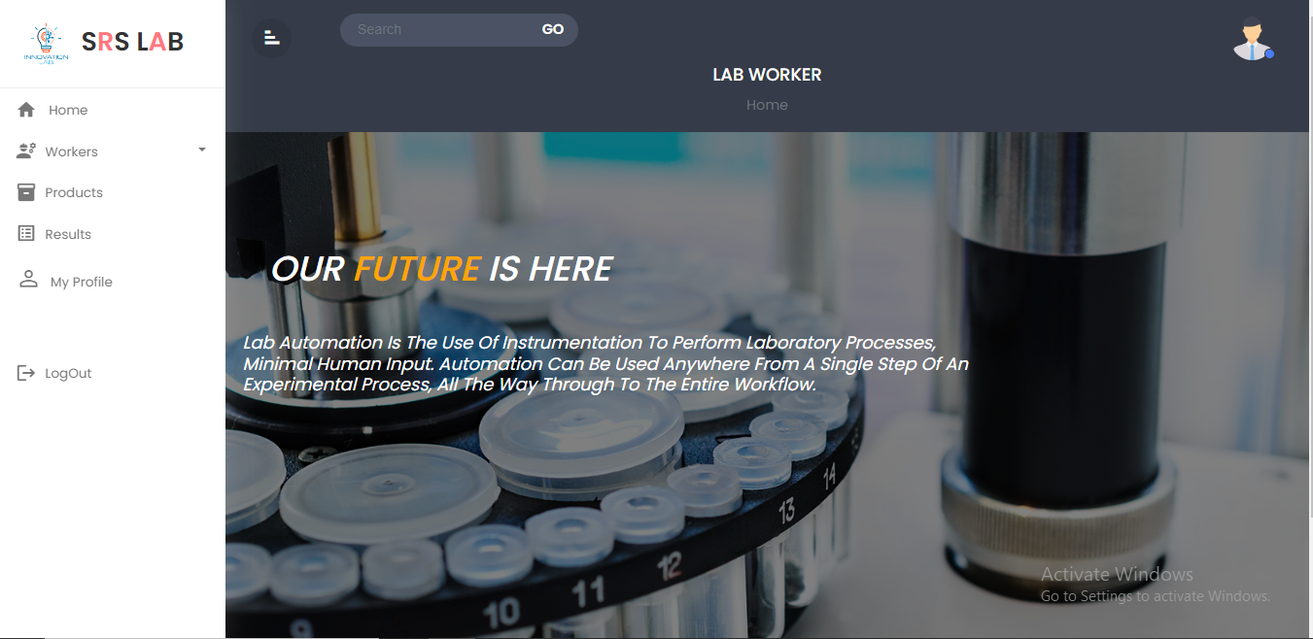

**“Section 8: “Lab Worker Details Page”**

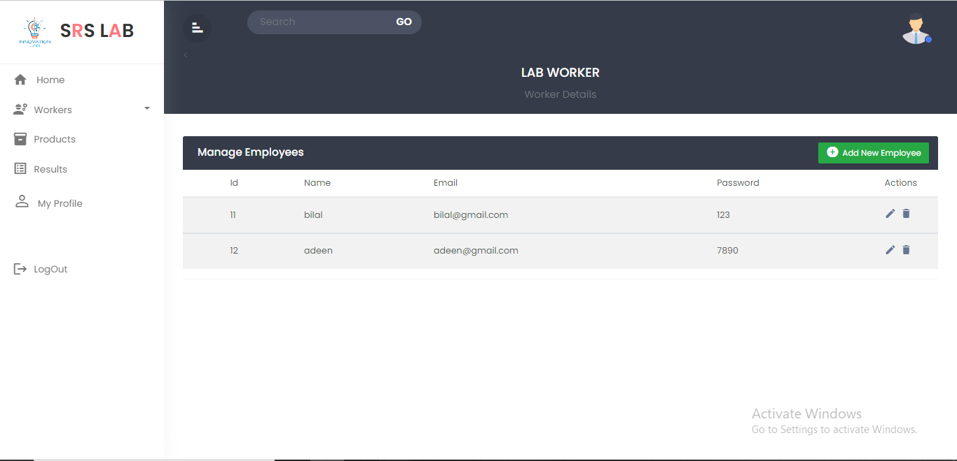

* **In this page worker view all worker details**

**“Section 9: “Create Lab Worker Page ”**

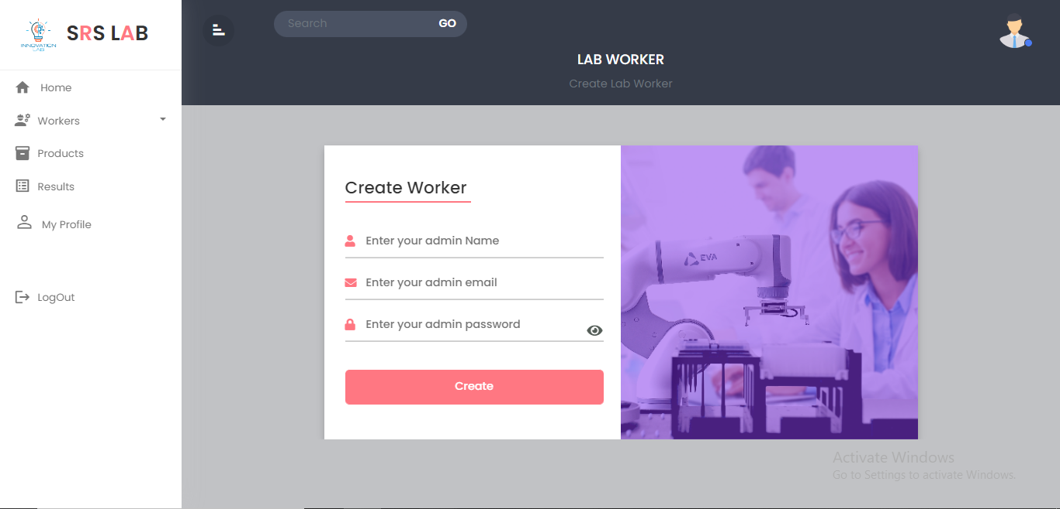

* In this page worker can create a worker account

**“Section 10: “Lab Worker Product Details Page”**

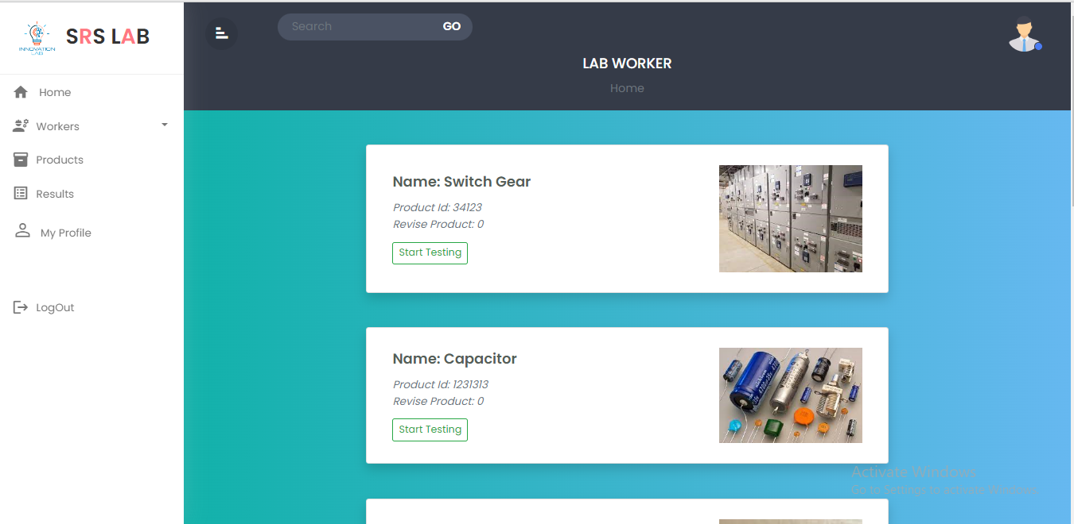

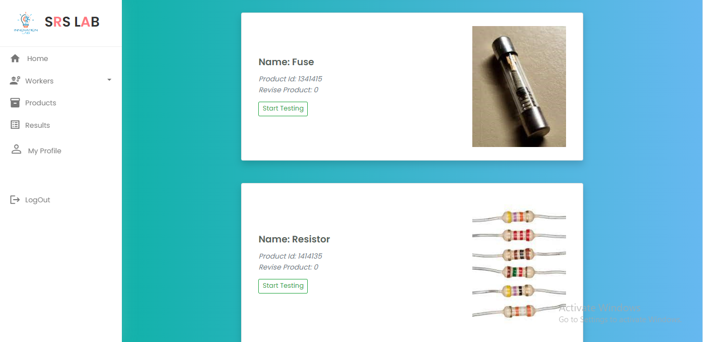

* In this page worker view the details of product customer sent for testing and by click on the start testing button it start testing

**“Section 11: “Lab Worker Details Page”**

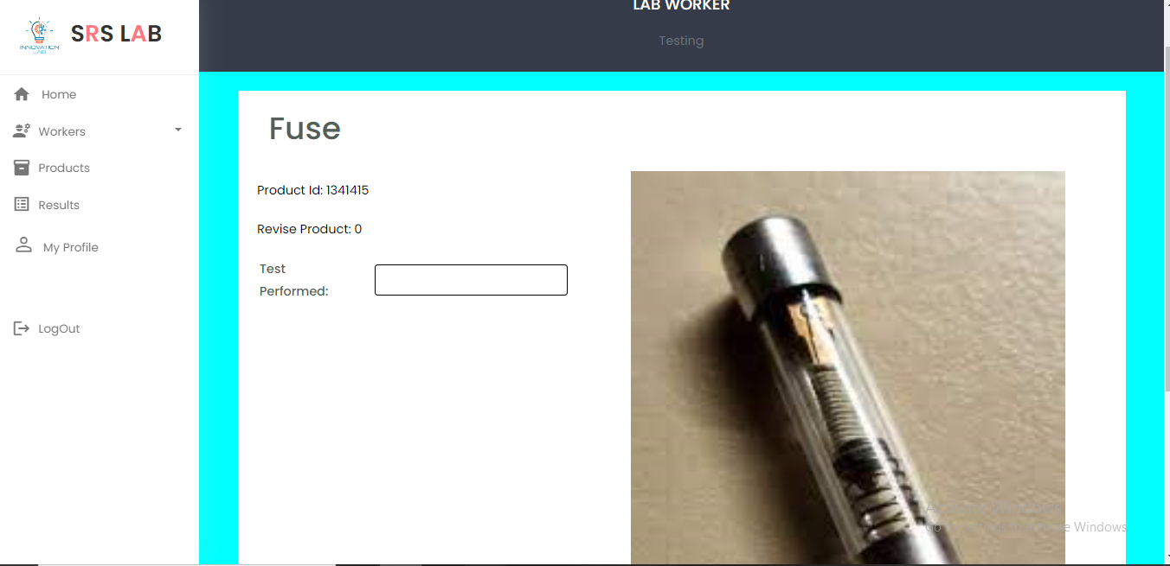

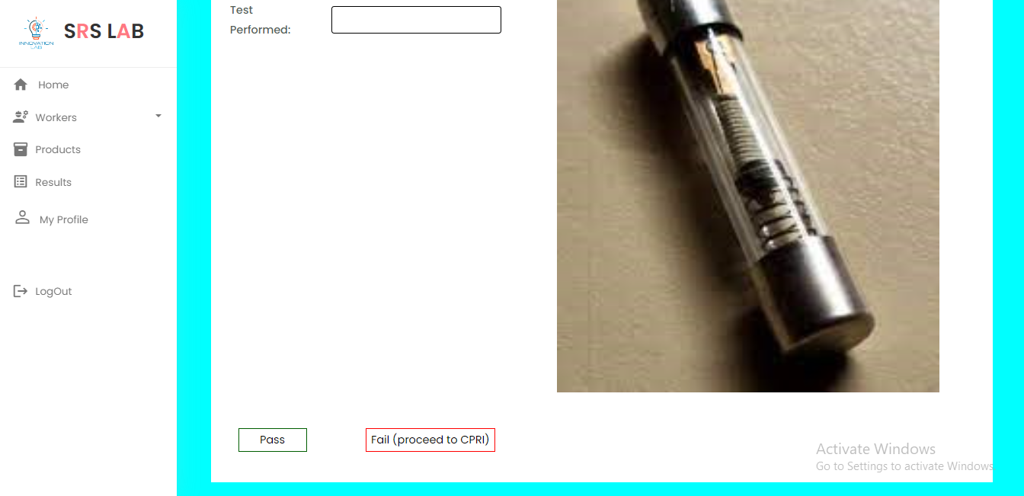

* In this page worker enter the test which has performed and by click on pass button the test was pass and product are eligible to release the in to the market.
* And by pressing fail button it will proceed to CPRI worker for further testing

**“Section 12: “Lab Worker Product Result Details Page”**

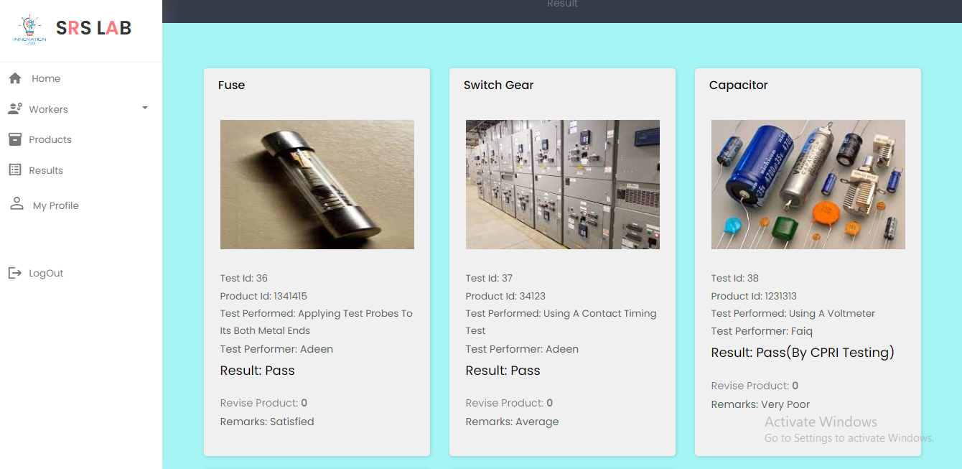

* **In this page Lab worker view the product results**

**“Section 13: “Lab Worker My Profile Page”**

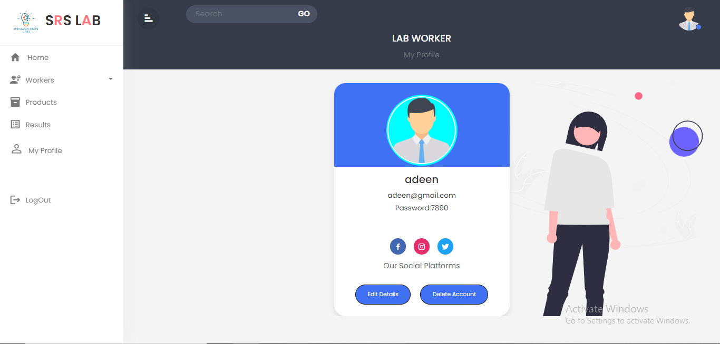

**“Section 14: “Lab Worker Edit My Profile Page”**

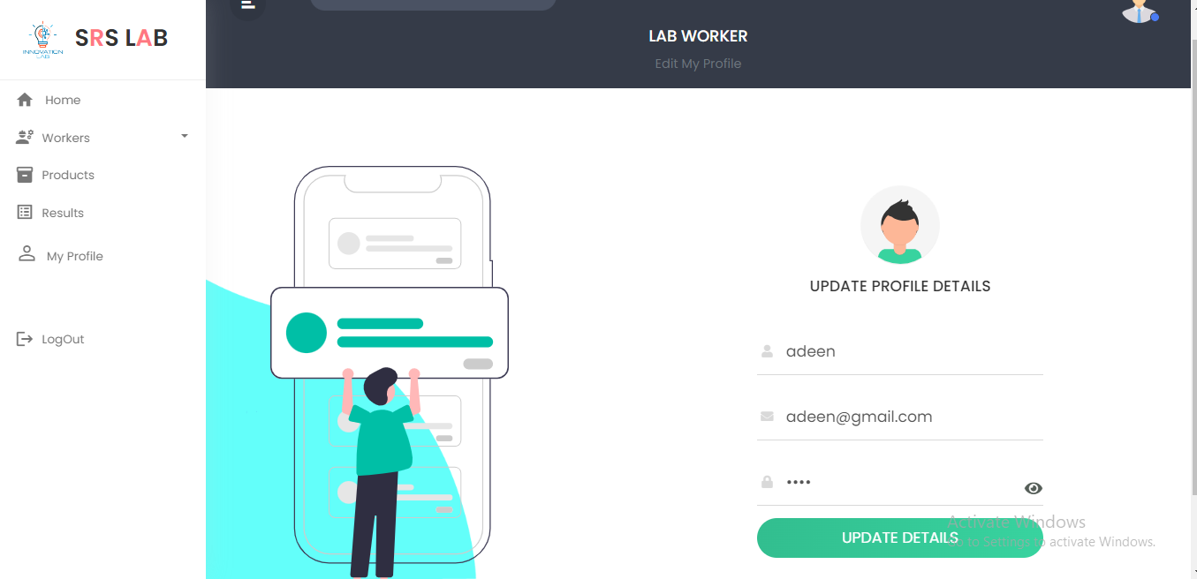

* **In this page Lab worker will update his profile details**

**“Section 15: “CPRI Worker Home Page”**





**“Section 16: “Create CPRI Worker Page”**



* In this page worker can create a worker account

**“Section 17: “CPRI Worker Details Page”**

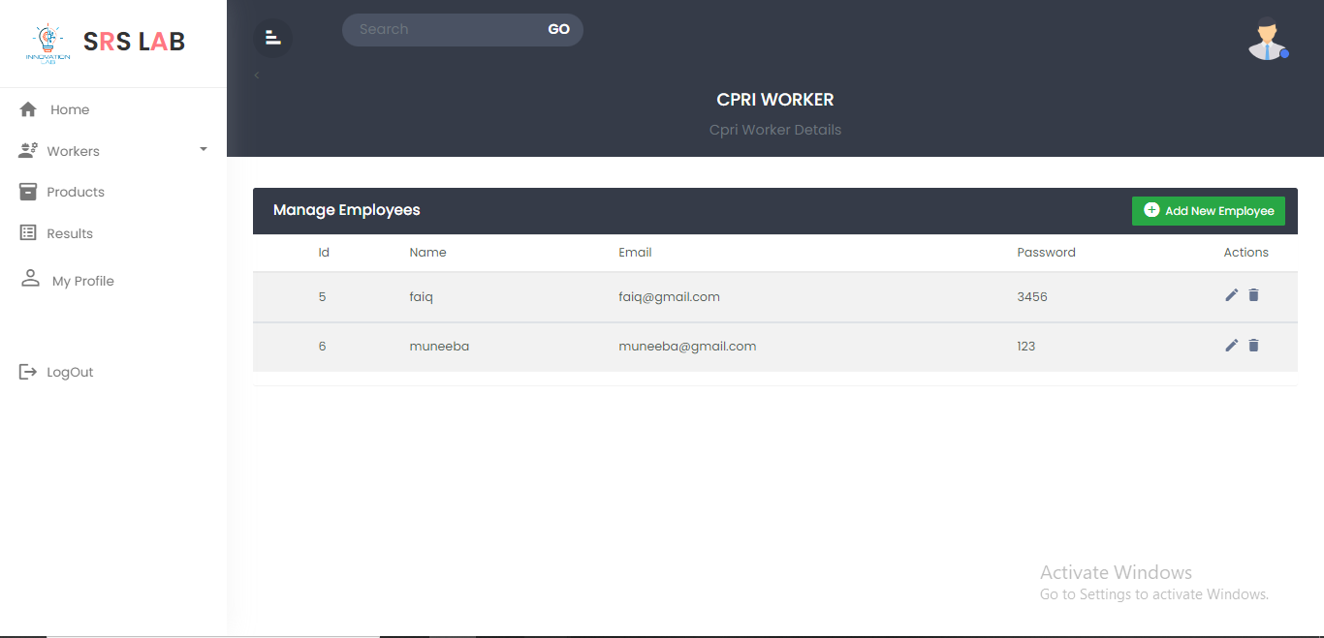

* **In this page worker view all worker details**
* **Section 18: “CPRI Product Details Page”**

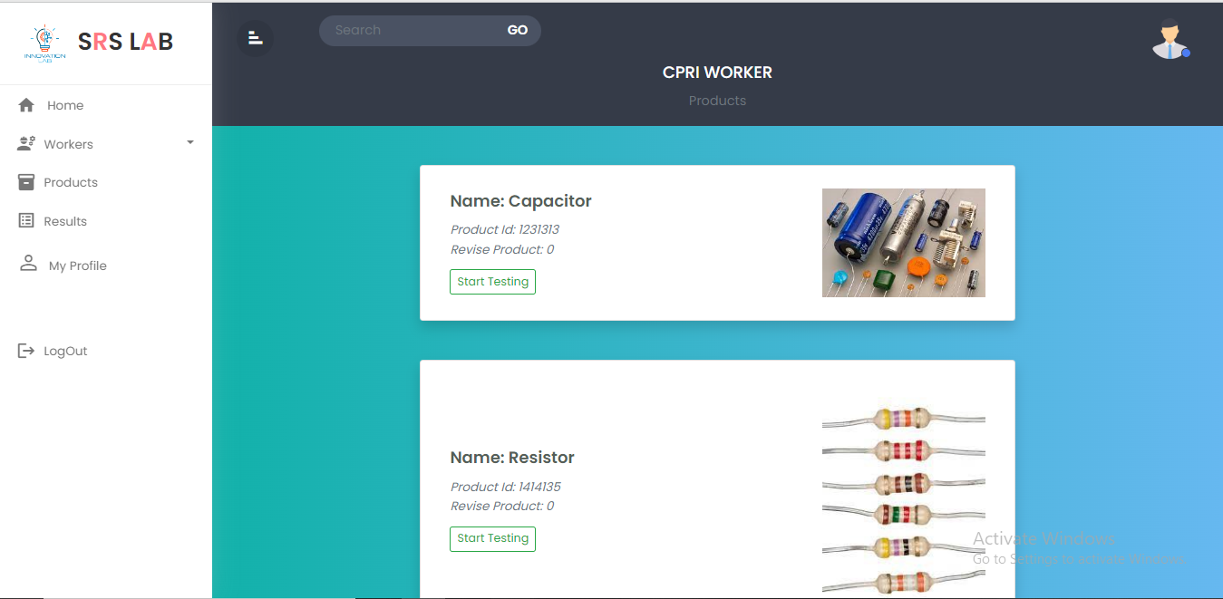

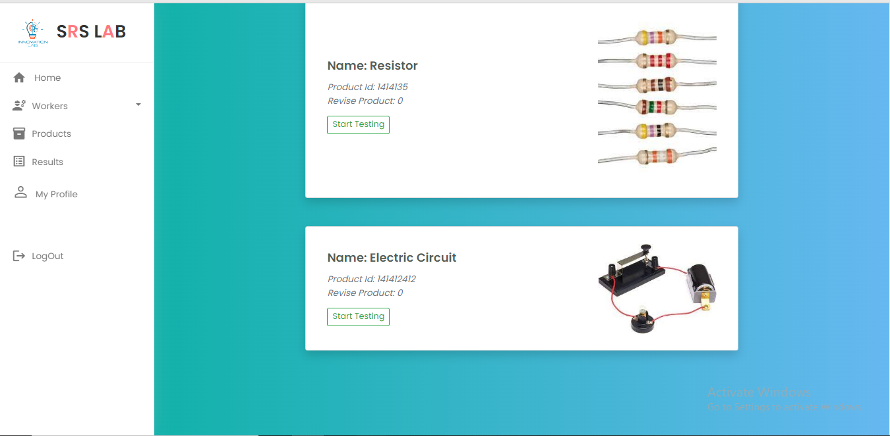

* In this CPRI worker view the product which are sent by Lab Worker

**Section 19: “CPRI Product Details Page”**

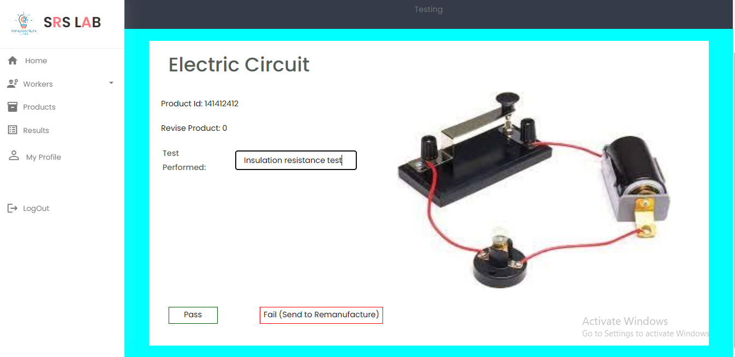

* **In this page CPRI worker fill the test details and by pressing pass button the product are free for released in market and by pressing fail it will return for remanufacture it**

**Section 20: “CPRI Product Result Page”**

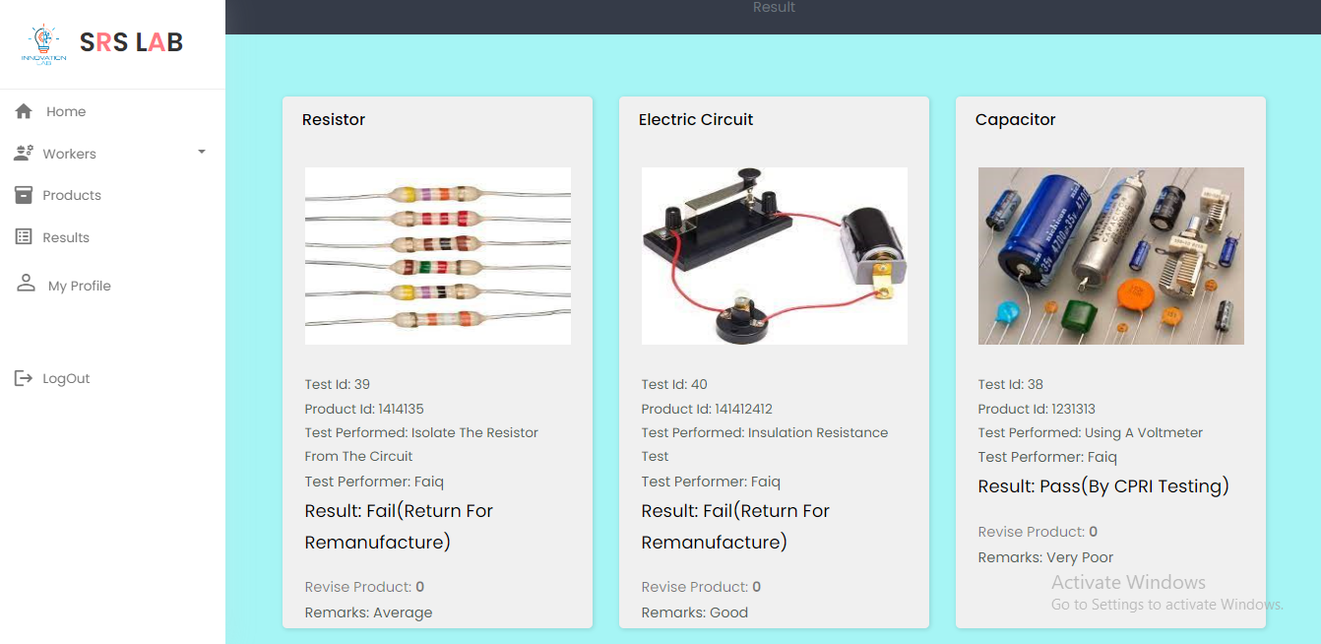

* **In this Page CPRI worker view the result of products**

**“*End*”**